

**BEACONHOUSE NATIONAL UNIVERSITY**

Course Resource Center & Testing System

**Design Document**

**INTERNAL SUPERVISOR**

Ms. Naureen Sheikh

**EXTERNAL SUPERVISOR**

Ms. Naureen Sheikh

**GROUP MEMBERS**

Saqib Majeed

Muhammad Adil

Naeem Khalid

**SCHOOL OF COMPUTER & INFORMATION TECHNOLOGY**

**System Architecture Diagram:**

# **E:\BNU Work\FYP 1\Untitled Diagram (2)(1).jpg**

# Our system works on MVC architecture, first portion Presentation Layer contains three components (Mobile UI views, Normal UI views, Controller). Second Portion Business layer contains two components (Request / Response, Application Services). Third portion Data Persistence / Access layer contains two components (Mapping / Data Model, Methods). Remote database accessed via all layers and all the actors access the views via website.

**PRESENTATION LAYER:-** Presentation is the application code that defines the logical behavior and structure of the application in a way that is independent of any specific user interface implementation. When implementing the Separated Presentation pattern, the presentation logic components may include Presenter, Presentation Model, and View Model components. The presentation layer may also include Presentation Layer Model components that encapsulate the data from your business layer, or Presentation Entity components that encapsulate business logic and data in a form that is easily consumable by the presentation layer.

**BUSSINESS LAYER:-** It will help you to understand how the business layer fits into the typical layered application architecture, the components it usually contains, and the key issues you face when designing the business layer. You will see guidelines for design, the recommended design steps, relevant design patterns, and technology options.

**DATA ACCESS LAYER:-** It will help you to understand how the data layer fits into the typical layered application architecture, the components it usually contains, and the key issues you face when designing the data layer. You will see guidelines for design, the recommended design steps, relevant design patterns, and technology options.

# **Database Diagram:**

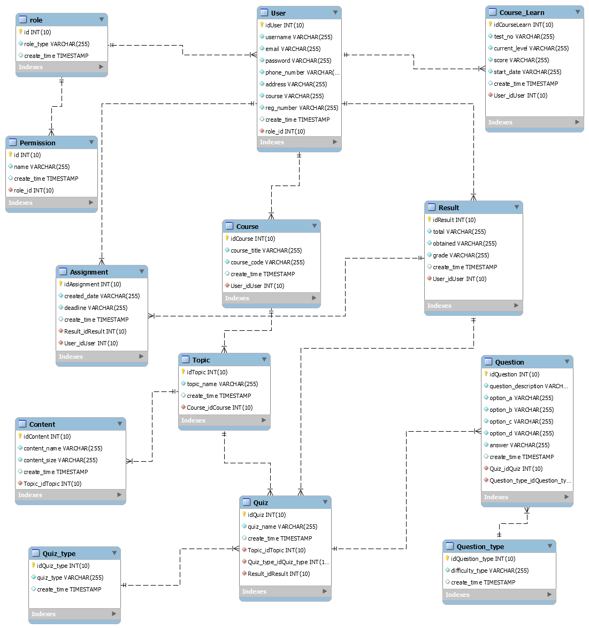

User table will handle the details of all types of user details, which can login to our site and perform functions based on their roles. There are 04 types of roles (Admin, Teacher, Student, and Guest). Here is many one to many relationships: - admin manages all students and teacher accounts, teachers can generate many quiz and assignments and course add or remove. Teachers add many subjects and topics, which they want. Guest also have one to many relationships many guests operate the website. Student learn course many times. Here is also one to one relationship that student check history and result of all the evaluation of the course.

**Class Diagram:**

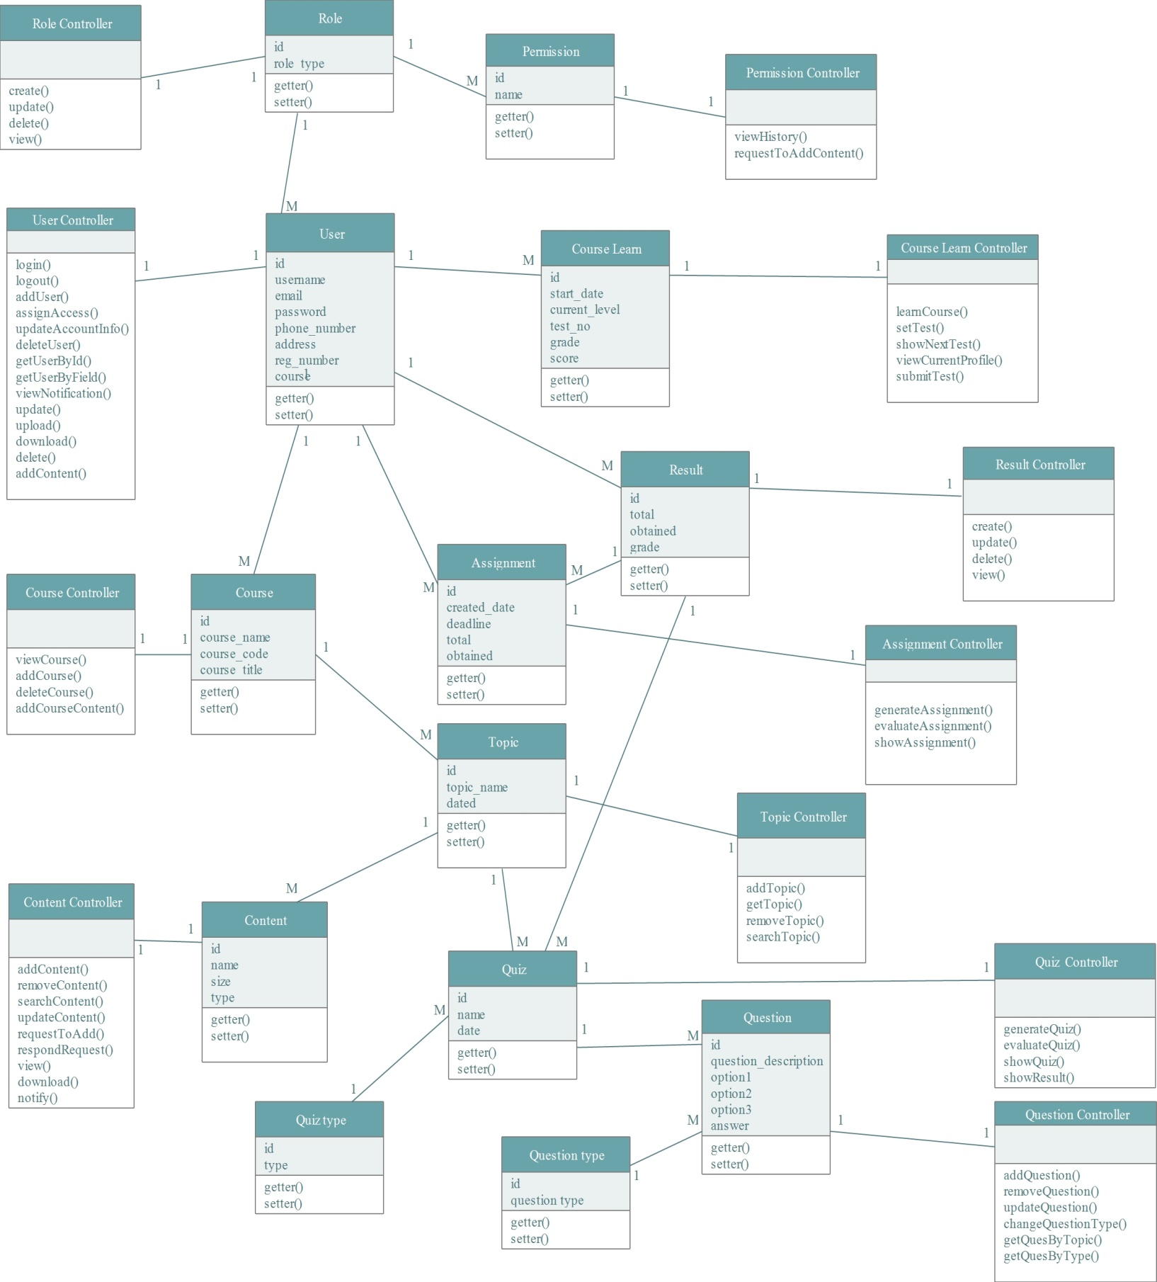

**Sequence Diagram**

**Login:**

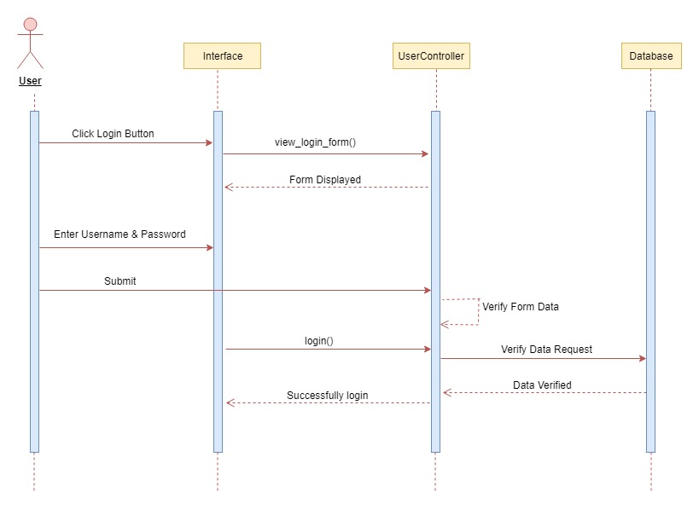

**Logout:**

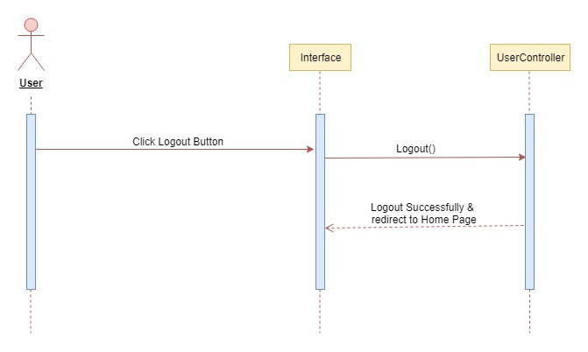

**Visit Website:**

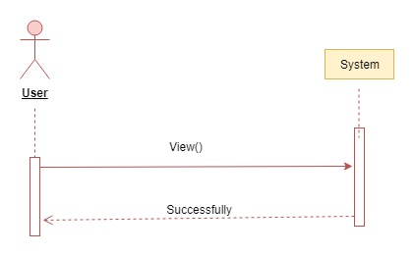

**Create Account:**

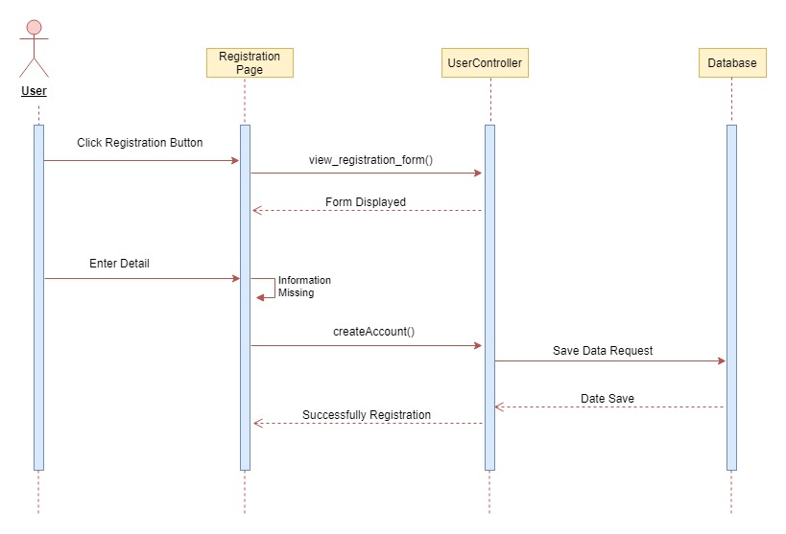

**Download:**

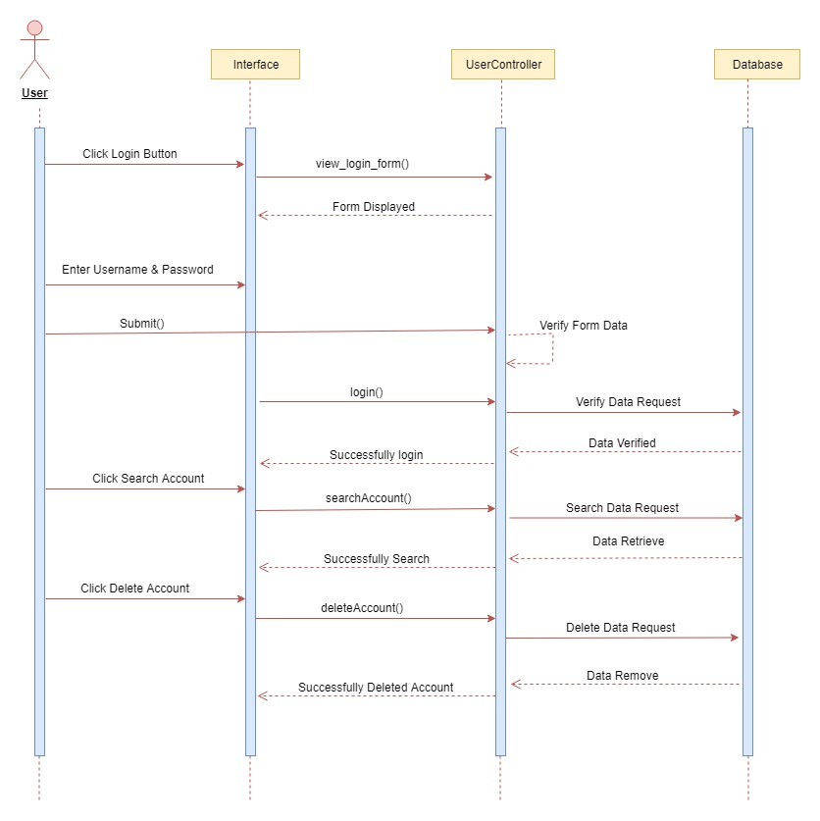

**Upload Content:**

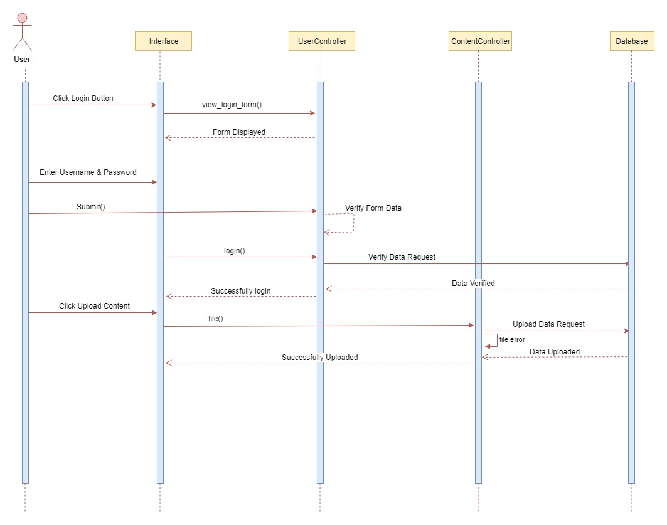

**Generate assignment:**



**Generate quiz:**

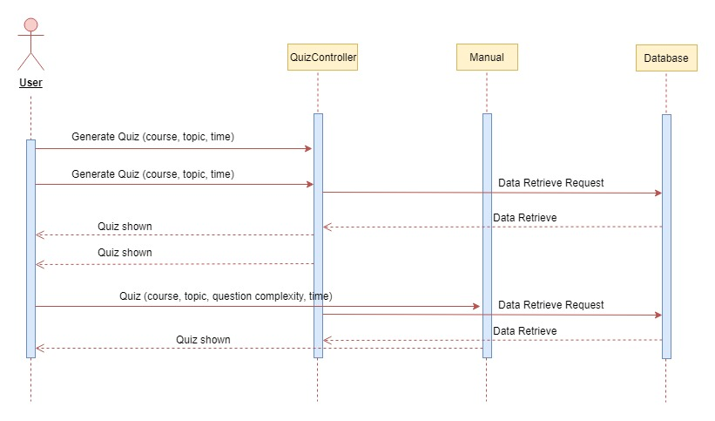

**Learn course:**



**Search content:**

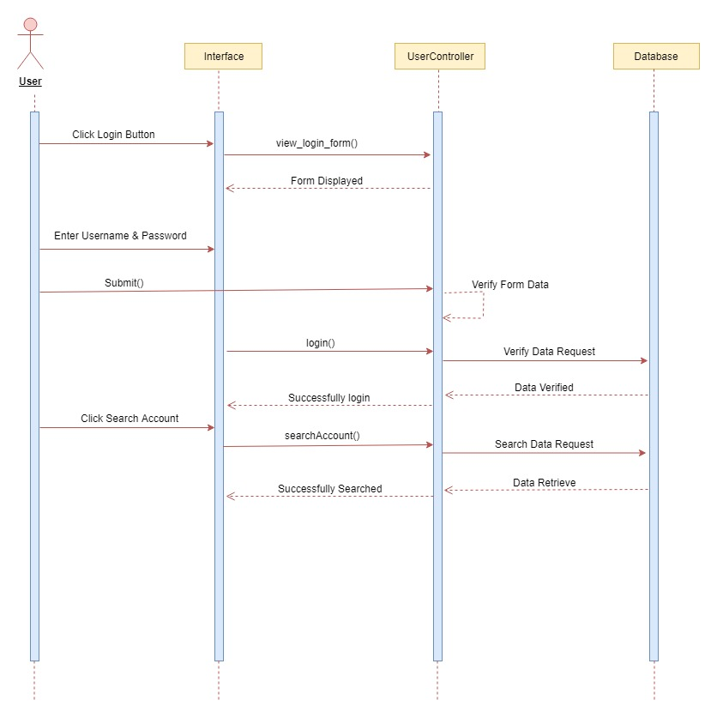

**Request to Add content:**

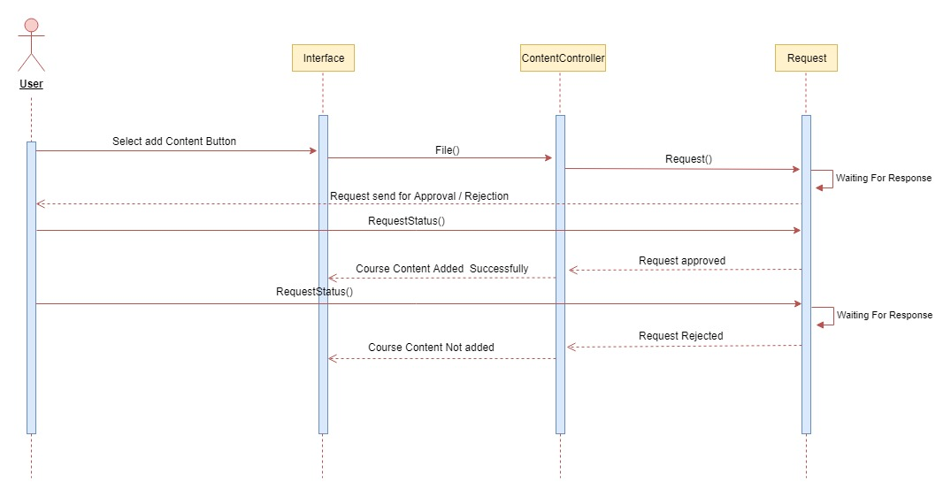

**Update Account Info:**

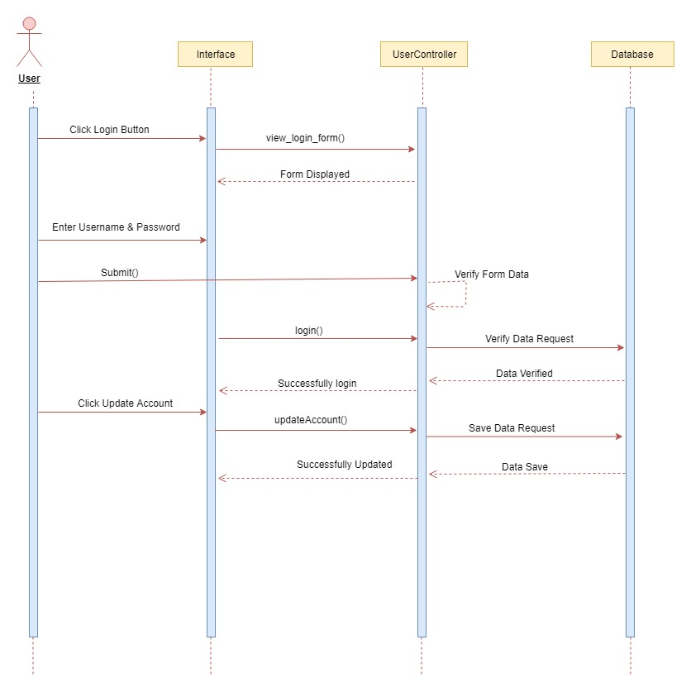

**Delete Account:**



**Search Account:**



**Check Quiz:**

